**Lab report no 1**



**Fall 2023**

# Web Engineering Lab

**Submitted By**

**Name Registration No**

# Muhammad Ali 19pwcse1801

Section: **A**

**Date**: 04,03,23

**Submitted to: Mam Madeha**

Department of Computer Systems Engineering

University of Engineering and Technology, Peshawar

**Task No 1: -**

**HMTL: -**

<!DOCTYPE html>

<html lang="en">

<head>

    <meta charset="UTF-8">

    <link rel="stylesheet" href="header.css">

    <title>Task n0 1</title>

</head>

<body>

    <header class="container">

        <div class="logo">🟢</div>

        <div class="tem">Categories</div>

        <div class="tem">Deals</div>

        <div class="tem">Trending</div>

    </header>

<p>Muhammad Ali</p>

</body>

</html>

**CSS: -**

*{

    margin: 0;

    padding: 0;

}

.container{

    display: flex;

    flex-direction: row;

    flex-wrap: nowrap;

    align-items: flex-start;

    align-items: center;

    background-color: darkgrey;

    height: 50px;

}

.tem{

    padding-left: 10px;

}

**Output: -**

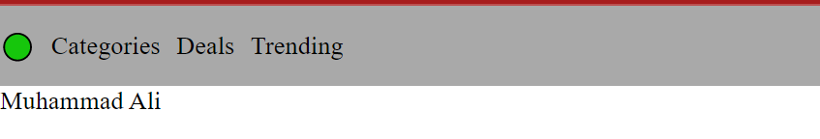

**Task No 2: -**

**HMTL: -**

<!DOCTYPE html>

<html lang="en">

<head>

    <meta charset="UTF-8">

    <link rel="stylesheet" href="nav_slide.css">

    <title>Task n0 2</title>

</head>

<body>

    <header id="container">

        <div class="item">Home</div>

        <div class="item">Music</div>

        <div class="item">Blog</div>

        <div class="item">Shows</div>

        <div class="item">Prodcast</div>

    </header>

<p>Muhammad Ali</p>

</body>

</html>

**CSS: -**

*{

    margin: 0;

    padding: 0;

}

#container{

    display: flex;

    flex-direction: column;

    background-color: darkgrey;

    width: 140px;

    height: 500px;

    font-weight: bolder;

    justify-content:space-between;

}

.item{

    padding-left: 5px;

}

**Output: -**

